Altium Designer

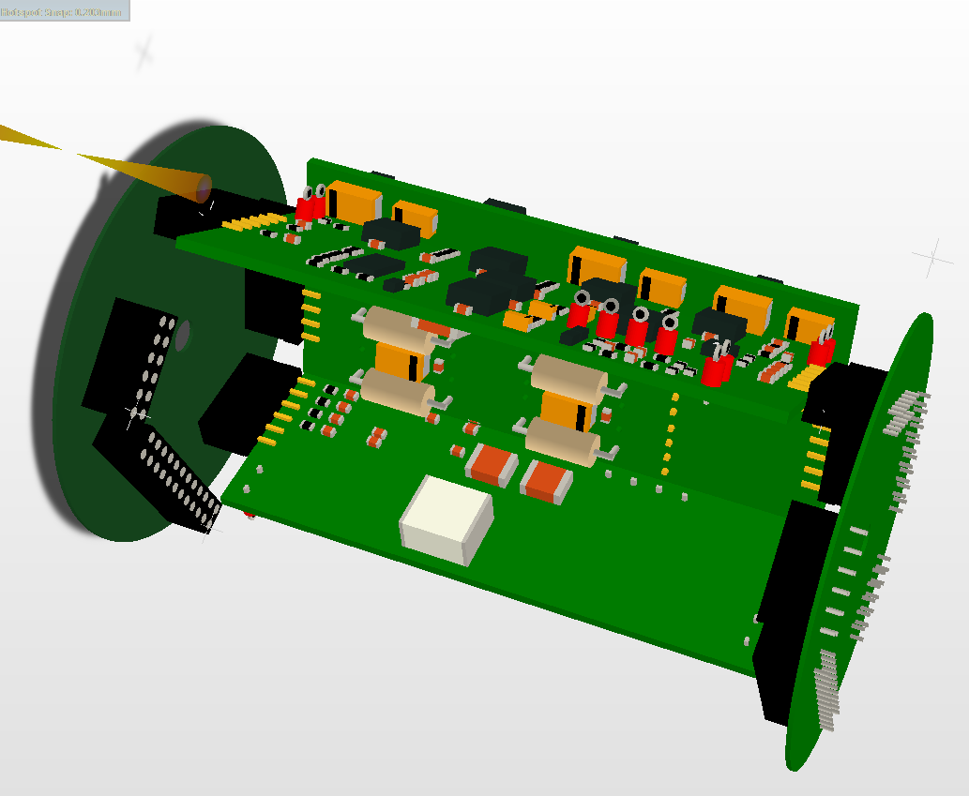

# **Introduction**

## **Document Content**

This document contains some information about how to start drawing a new Schematic and Pcb using Altium Designer.

# **Table of Contents**

**1.** **Introduction** 2

**1.1** **Document Content** 2

**2.** **Table of Contents** 2

**3.** **New Project** 3

**3.1** **Validate a License** 3

**3.2** **Creating a new Project** 3

**3.3** **Adding a Schematic Sheet** 3

**3.4** **Defining the Project Parameters** 4

**3.5** **Numbering Schematic Sheets** 4

**3.6** **Saving the Project** 4

**4.** **Schematic capture** 6

**4.1** **Setting the Libraries** 6

**4.2** **Placing Parts** 7

**4.3** **Wiring Components** 7

**4.4** **Ports and Labels** 8

**4.5** **Schematic Annotation** 8

**4.6** **Hierarchical Schematic** 8

**4.7** **Enter the Parts Values** 9

**4.8** **Schematic Compilation** 10

**4.9** **Function NoERC** 10

**4.10** **Print** 10

**5.** **PCB Design** 11

**5.1** **Grid Setting** 11

**5.2** **Defining Origin** 11

**5.3** **Drawing Board Outline** 11

**5.4** **Importing the Components** 12

**5.5** **Move and Place Components** 12

**5.6** **Setting the Design Rules** 12

**5.7** **Placing Tracks** 13

**5.8** **Placing Vias** 13

**5.9** **Placing Polygon Pour** 13

**5.10** **Design Rules Check** 14

**5.11** **Files Output** 14

**5.12** **Print Drill Table** 15

**6.** **Tips & Tricks** 16

**6.1** **Help** 16

**6.2** **3D** 16

**6.3** **Zoom** 16

**6.4** **Selecting multiple objects** 16

# **New Project**

## ****Validate a License****

Click on **DXP** menu ->**My Account**- > **Setup private license** server and enter License server parameters.   
  
Server name : altiumlm.hevs.ch  
Server Port : 21001  
Right click on Altium Designer and choose **Activate License**.

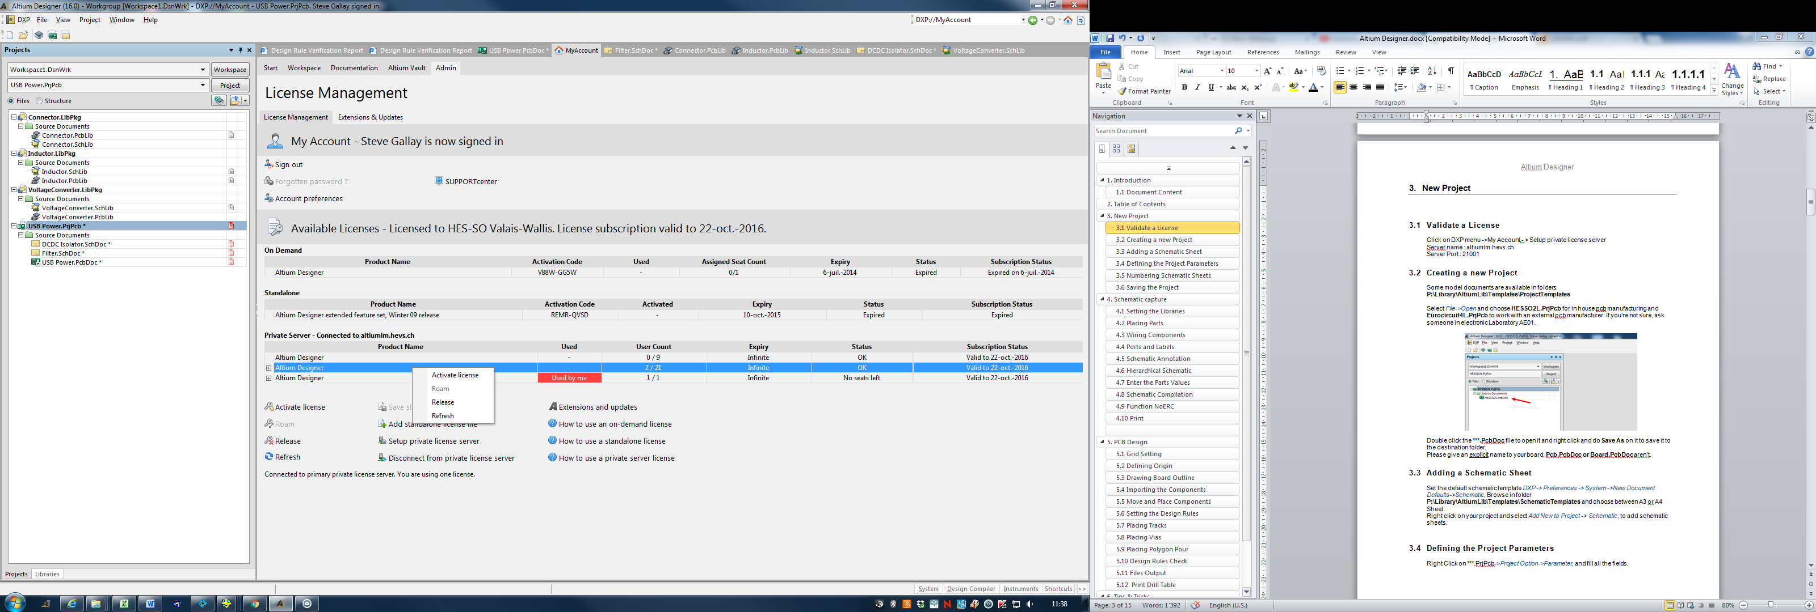

## ****Creating a new Project****

Some model documents are available in folders:

**P:\Library\AltiumLib\Templates\ProjectTemplates**

Select *File->Open* and choose **HESSO2L.PrjPcb** for in house pcb manufacturing and **Eurocircuit4L.PrjPcb** to work with an external pcb manufacturer. If you’re not sure, ask someone in electronic Laboratory AE01.

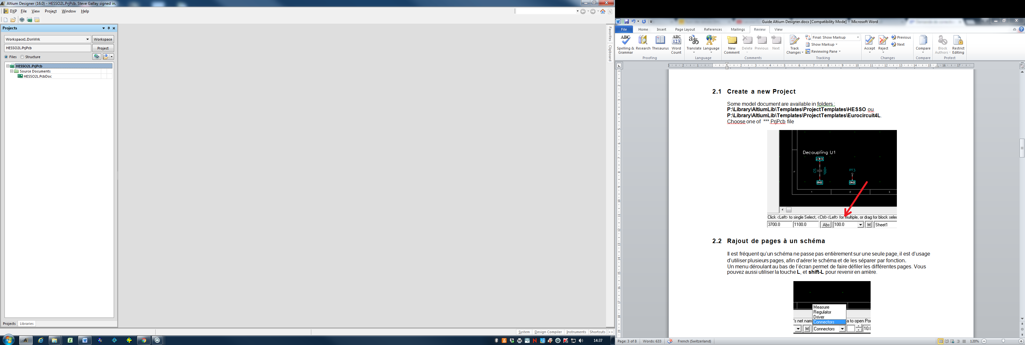

Double click the **\*\*\*.PcbDoc** file to open it and right click and do **Save As** on it to save it to the destination folder.  
Please give an explicit name to your board, **Pcb.PcbDoc** **or Board.PcbDoc** aren’t.

## **Adding a Schematic Sheet**

Set the default schematic template *DXP -> Preferences -> System ->New Document Defaults->Schematic*, Browse in folder P**:\Library\AltiumLib\Templates\SchematicTemplates** and choose between A3 or A4 Sheet.

Right click on your project and select *Add New to Project -> Schematic*, to add schematic sheets.

## **Defining the Project Parameters**

Right Click on ***.PrjPcb->*Project Option->Parameter*, and fill all the fields.

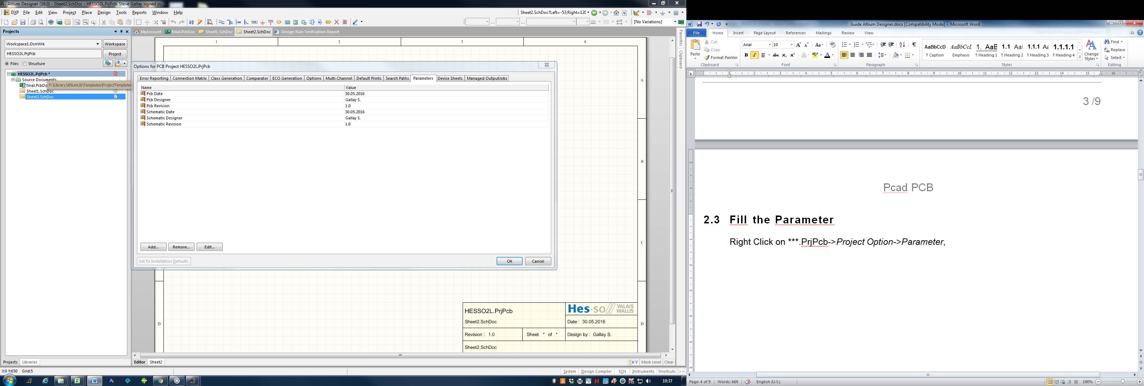

## **Numbering Schematic Sheets**

Select menu *Tool->Number Schematic Sheets* and *Auto Sheet Number, Auto Document Number, Update Sheet Count.*

## **Saving the Project**

Now right-click on **\*\*\*.PrjPcb** file and select ***Save Project As***, enter project name and choose the right destination folder.   
Altium will ask you a name for the **\*\*\*.SchDoc**. Give an explicit name to the different sheets.

Now your Project should looks like:

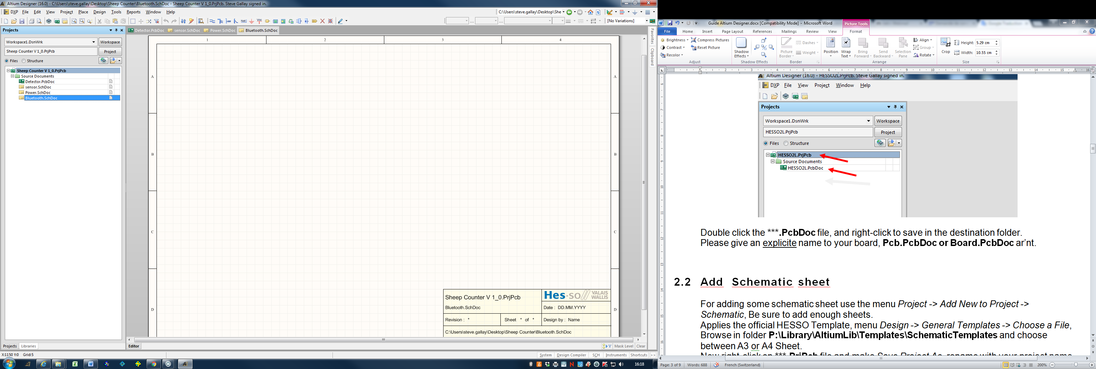

# **Schematic capture**

## **Setting the **Libraries****

Click *System->Libraries* on the bottom left of your screen

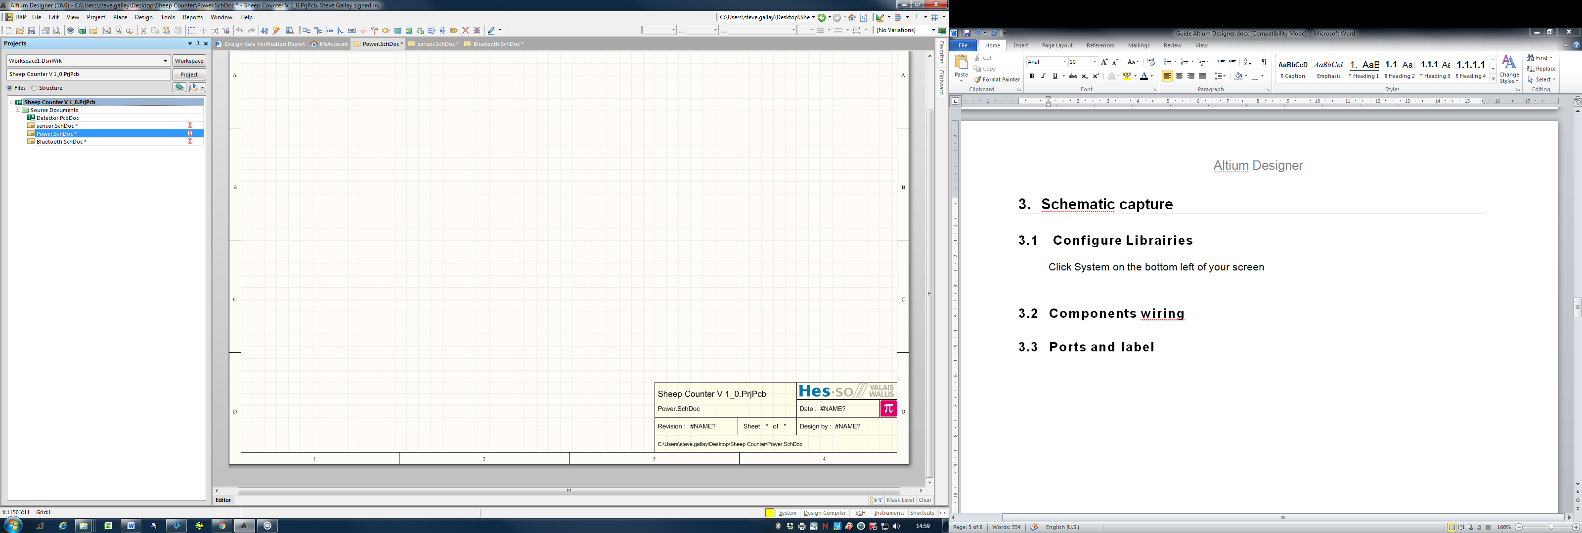

Click the *Libraries* button and chose *Installed->Install->Install from file…*Browse and select all the**\*\*\*.IntLib** filesin folder**P:\Library\AltiumLib.**Don’t use the other libraries.

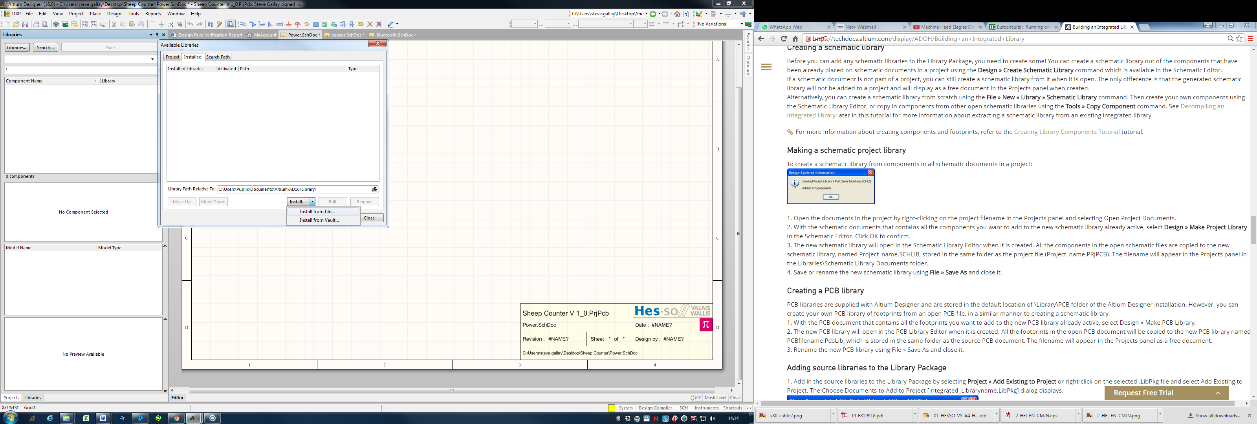

## **Placing Parts**

Now you can start placing your components, browse the libraries, chose the pattern you want and drag and drop it to your schematic. Alternately you can use the shortcut key **P-P** (Place-Part…).  
Use the **Space-bar** to rotate components, and **X**, **Y** keys to flip them.

Don’t forget to add mechanical parts as screws for example.

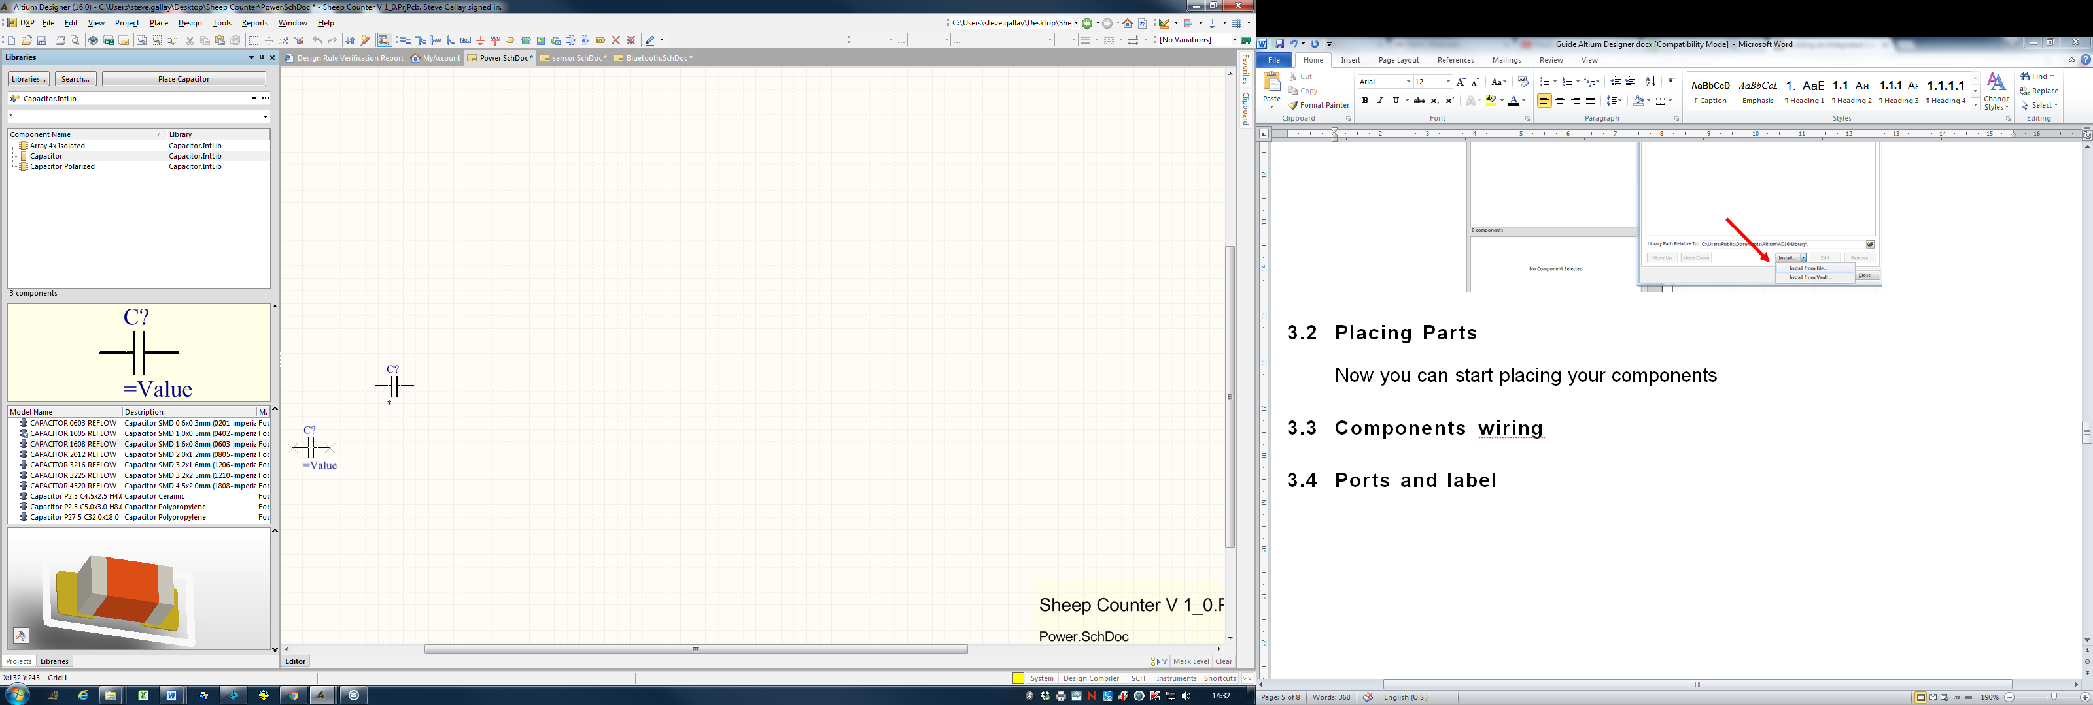

## **Wiring Components**

Use button to draw connections between components.  
Alternately you can use the shortcut **P-W** (Place-Wire).



It is useful to keep a large grid. The grid can be changed with the **G key**.

## **Ports and Labels**

Altium doesn’t connect Ports and Labels together.  
You can choose some different connection method in *Project->Project Options->Options->Net Identifier Scope*

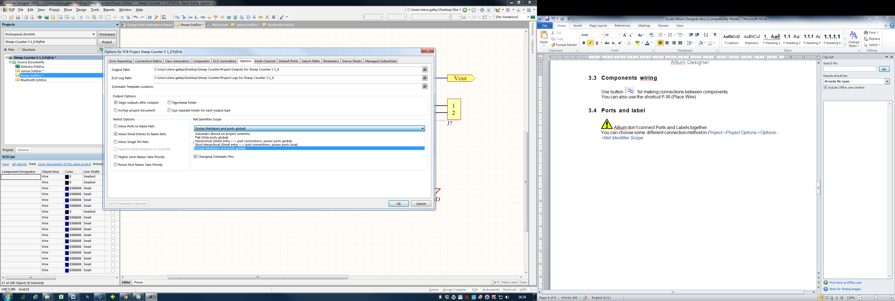

Use buttons to place NetLabel and to place Port.



The corresponding shortcut are **P-N** (Place-Net Label), **P-R** (Place-Port).

Use buttons to place GND and VCC Power Port.



The corresponding shortcut is **P-O** (Place-Power Port).

It’s preferable to check the option **Allow Ports to Name Nets**.

## **Schematic Annotation**

Use the command *Tools-> Annotate Schematic Quietly* if you don’t need any special features.

With the command *Tools-> Annotate Schematic…* you can choose between some different annotation methods.

## **Hierarchical Schematic**

For placing an Entire Schematic Sheet use the command *Place-> Sheet Symbol.*Double click on the green square and choose the linked schematic sheet you want to link.

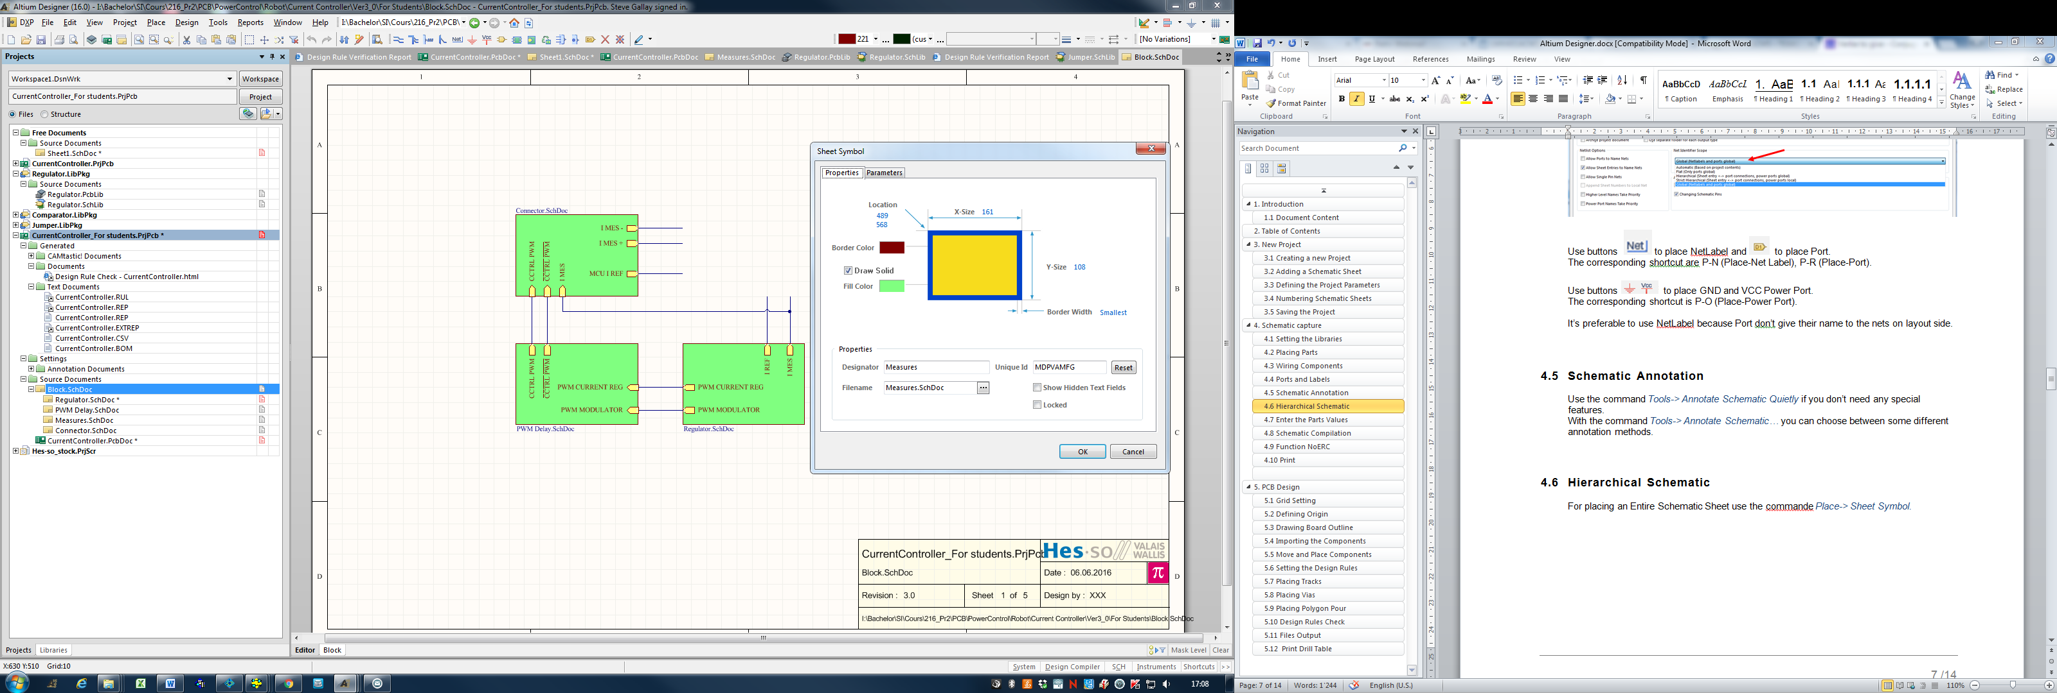

Use the command *Place-> Add Sheet Entry* for make connection between the different sheets

## **Enter the Parts Values**

Double Click on a part to enter the value

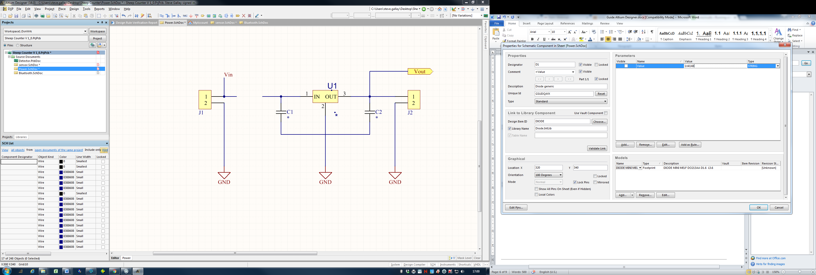

Note that the values 100n, 0.1u, 100nF, 1000p, 0.01uF will be interpreted as different values generating several entries in the bill of material. It is therefore important to always use exactly the same value string for the same components.

A good practice is to use a clear and full numbering with units (except for resistor) as shown below:

* 100nF
* 1uF
* 4.7uF
* 10mF
* 100mH
* 1.3k
* 0.1R
* 1.2R

## ****Schematic Compilation****

To compile the Schematic right click on your **\*\*\*.PrjPcb** file and select ***Compile PCB Project ***.PrjPcb***

If there is error during the compilation a Message windows appear.  
This window don’t open automatically in case of Warning. However, it is advisable to have a look at this Message windows: select *System-> Messages*

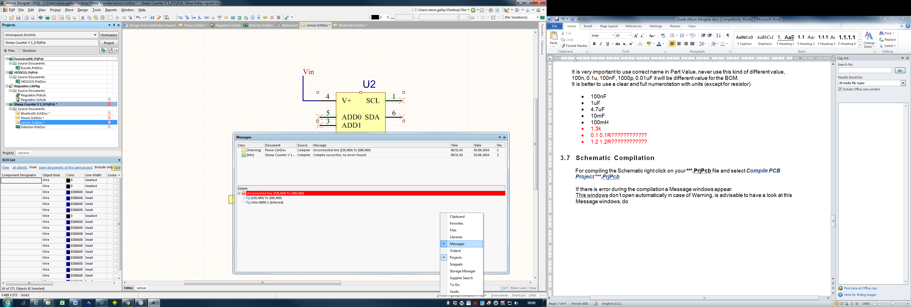

## **Function NoERC**

It’s possible to hide unwanted compilation warning/error by placing a NoERC mark on components pins. To do this, use the NoERC button.

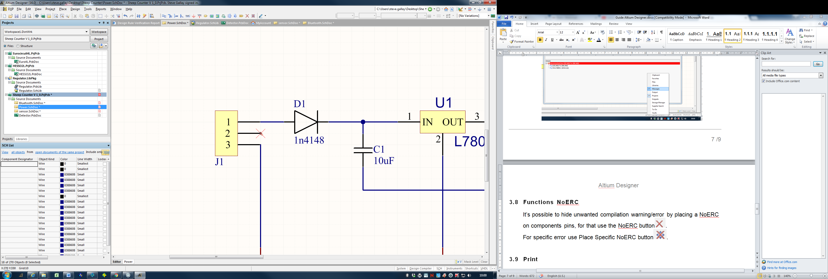

To hide a specific error use the Place Specific NoERC button.



## **Print**

To print the schematic, the easiest way is to use the menu *File->SmartPDF*.

# **PCB Design**

## **Grid Setting**

Choose between Metric and Imperial measurement with *Design->Board Options*.

If you can, it is preferable to use a metric grid.

Use the G key to modify the grid settings. Prefer a large grid, for example 1mm.

## **Defining Origin**

You can change the origin of the grid by selecting *Edit->Origin->Set*. Click the location where you want the 0.0 point, commonly the bottom left of your pcb.

## **Drawing Board Outline**

Set an adapted grid with the **G key.** Double click on the LS button (Layer Stack) and ensure that Layer Mechanical 1 is enabled.

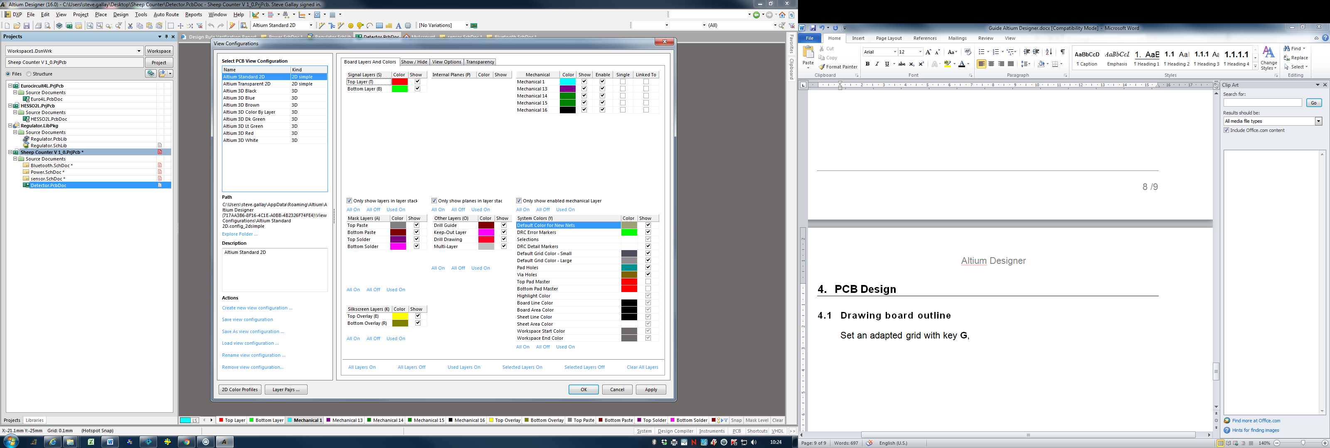

Change the active layer with the * key on the numeric pad, adjust the lines on the Mechanical 1 layer or draw a new board outline using the command Place-Line (**P-L**). To edit the line parameter, press the **TAB key**.

Select all the lines on Layer Mechanical 1, and select *Design->Board Shape->Define from selected objects*,now your pcb have the new dimensions.

## **Importing the Components**

Select *Design->Import Change from ***.PrjPcb,* click *Validate Changes, Execute Change*, then *Close*.

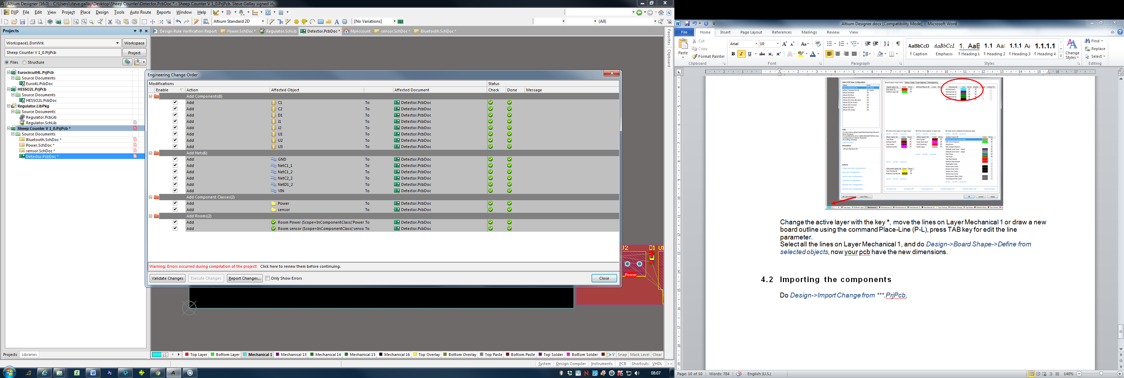

## **Move and Place Components**

The components can be moved using the mouse. Use the Space-bar to rotate components, and the **L key** to change the component Layer. The **G** **key** allows changing the grid setting: a large grid is preferable for placing components.

## **Setting the Design Rules**

Open Menu *Design->Rules*, then enable and set the base rules as show in picture below:

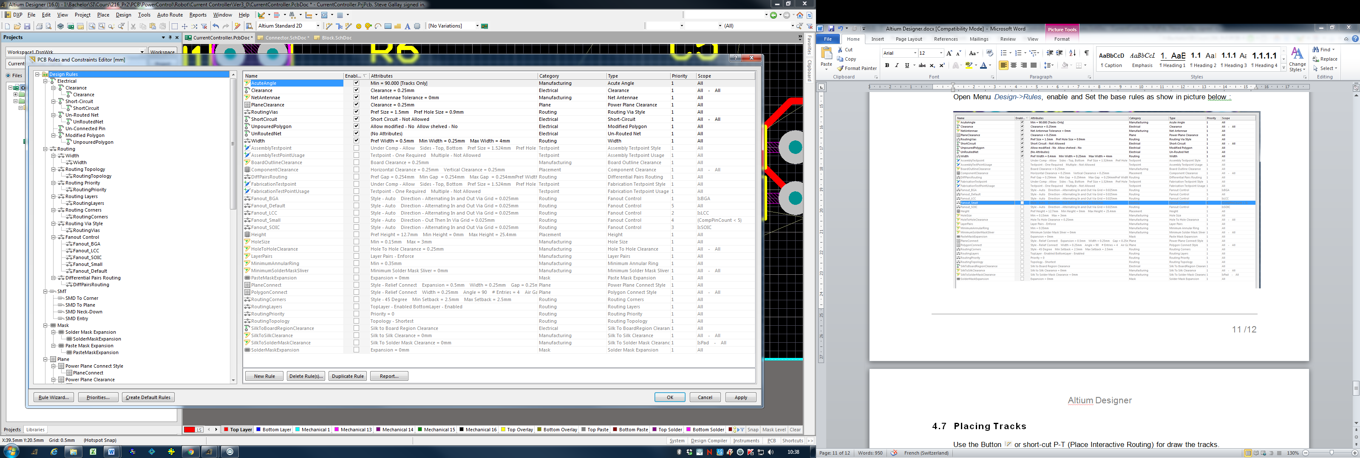

## **Placing Tracks**

Use the Button or short-cut **P-T** (Place Interactive Routing) to draw the tracks.

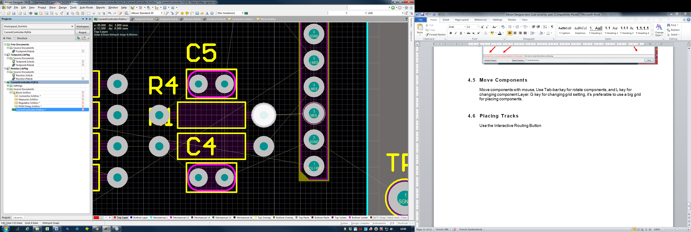

Push **Tab Key** if you want to edit routing parameter.  
Push **\* key** on the numeric pad to change routing layer.

Push **shift + Space-bar** for change routing style.  
Push **Space-bar** for change

## **Placing Vias**

To add a via simply push the **\* key** on the numeric pad during routing,   
or the shortcut **P-V** (Place Via).  
HESS-SO via capability is v160h90 ( Pad 1.6mm Hole 0.9mm).

## **Placing Polygon Pour**

Use the Button or the shortcut **P-G** (Place Polygon Pour) to draw a copper pour.

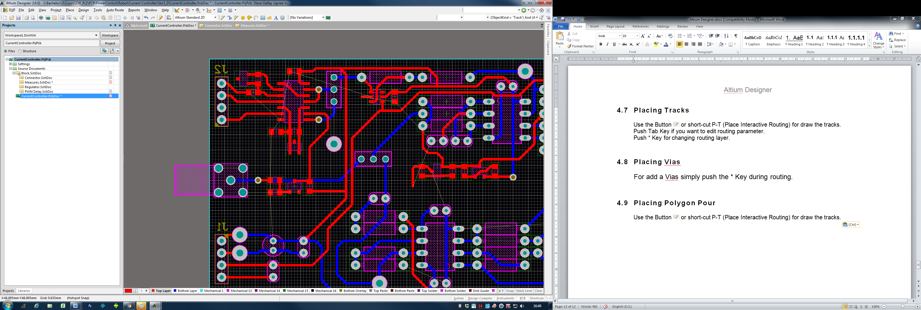

Select the layer, the net you want to pour and the connections style.

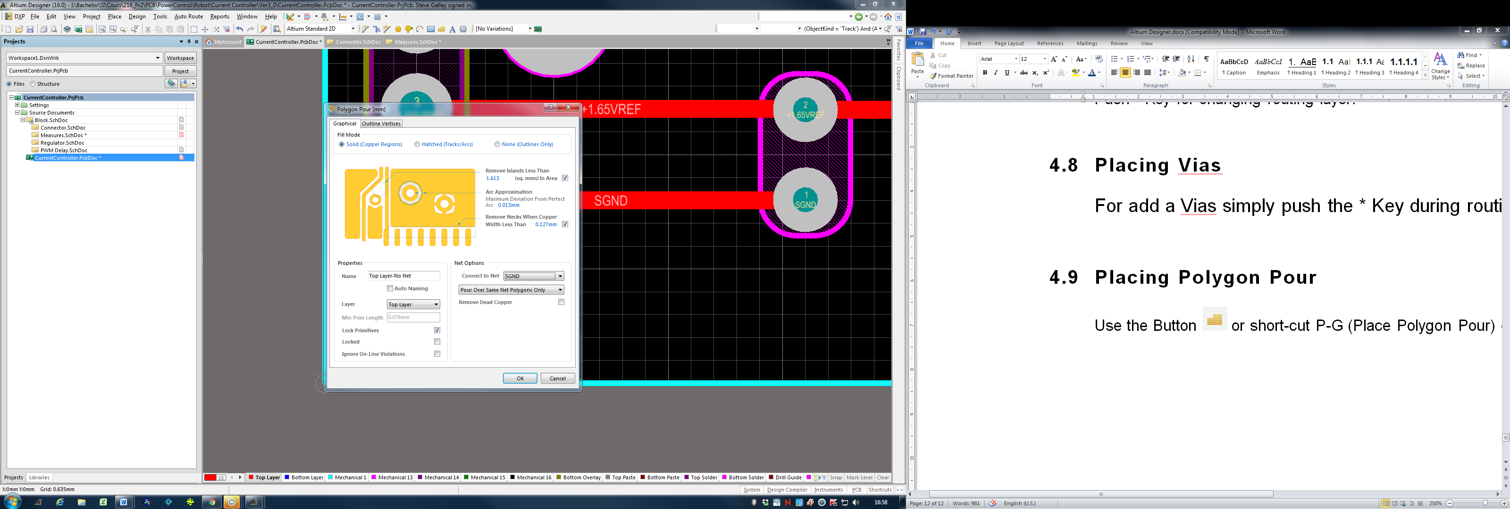

Select the connections style with *Design->Rules->PolygonConnect*

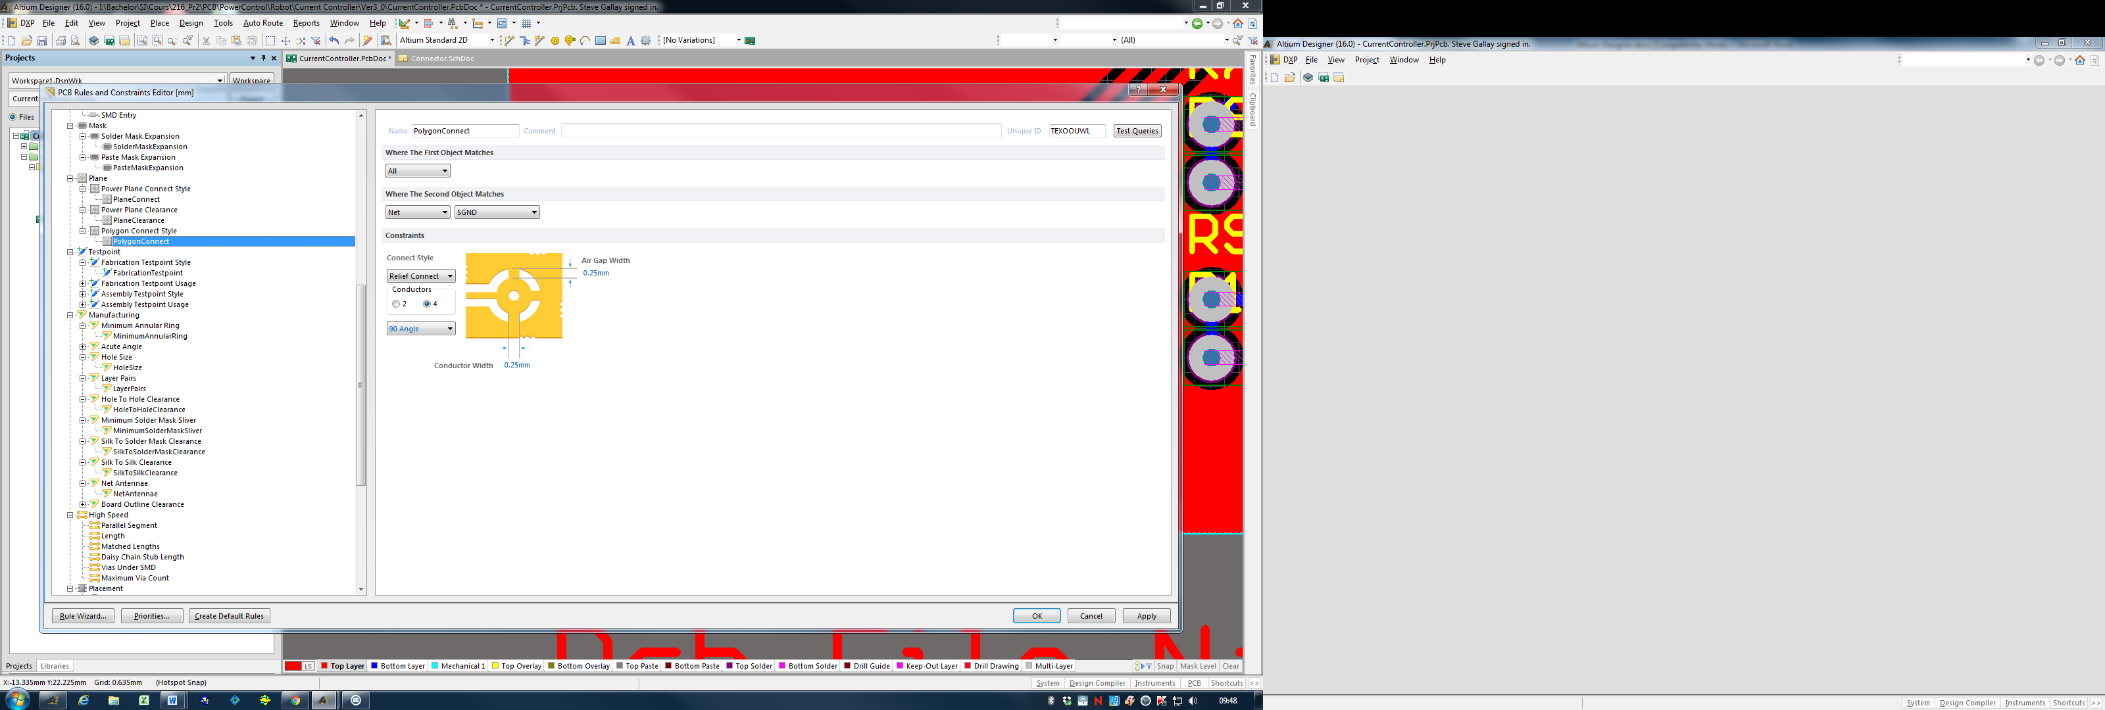

Ensure that the “Polygon Connect” rule is enabled.

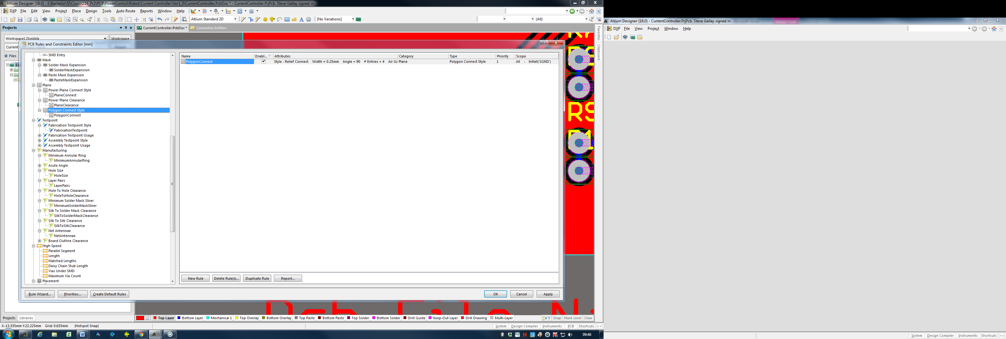

## **Design Rules Check**

Check your PCB with function *Tools->Design Rule Check-> Run Design Rules Check.* Choose which rules you want to check:

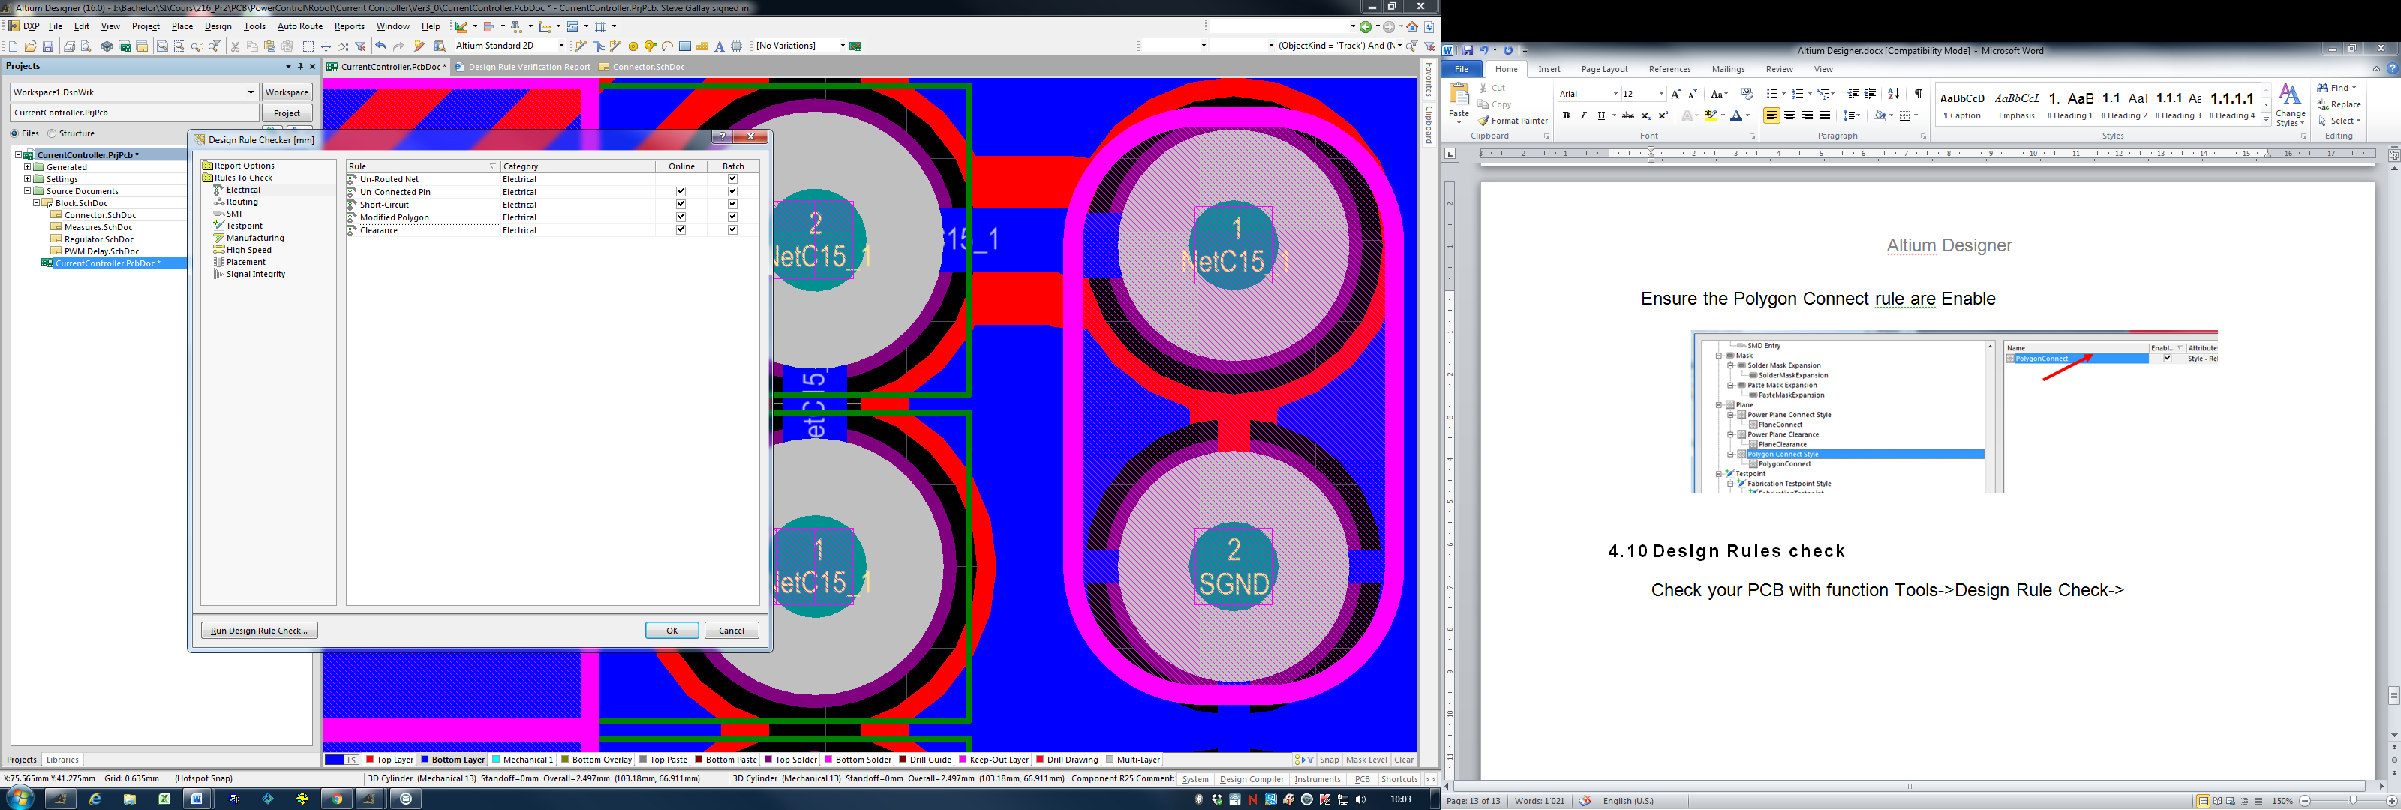

## **Files Output**

Use the function *File->Fabrication Outputs-> Gerber Files.*Select Millimeters 4:4, and which layer you want to print

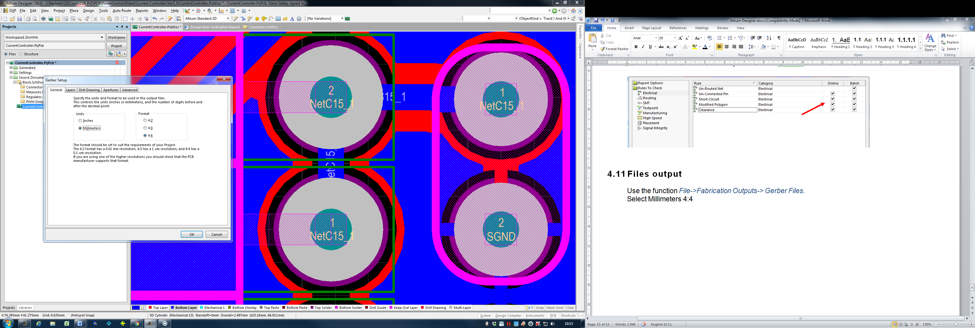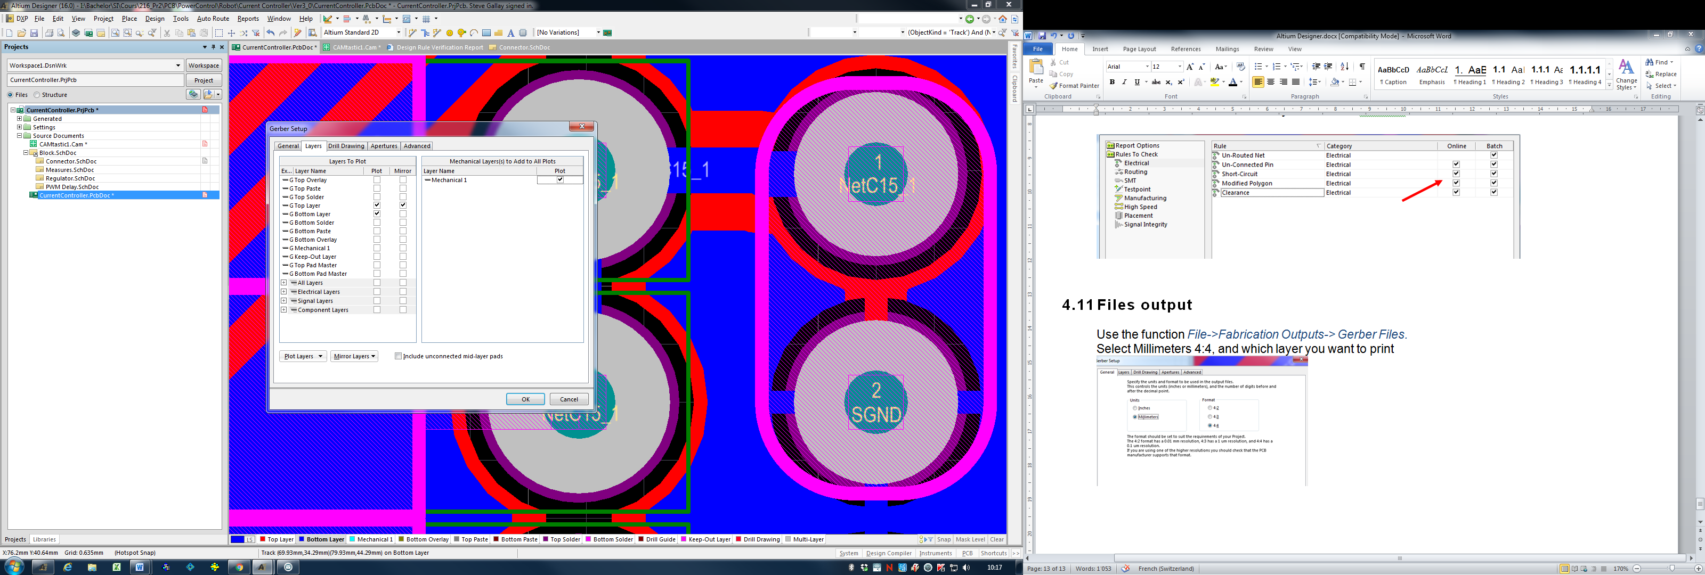

Altium open a new CAMtastic window, select *File->Print* if you want to print your layer.  
Scale must to be set to 1.0.

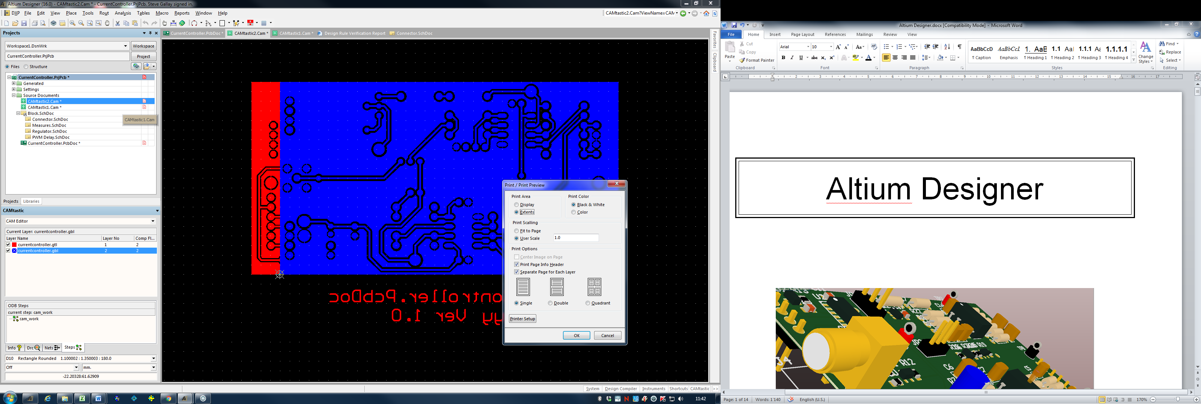

## **Print Drill Table**

Select the Menu *Place->Drill Table*, and then the Menu *File->Fabrication Output->Drill Drawing* and use the Print button.

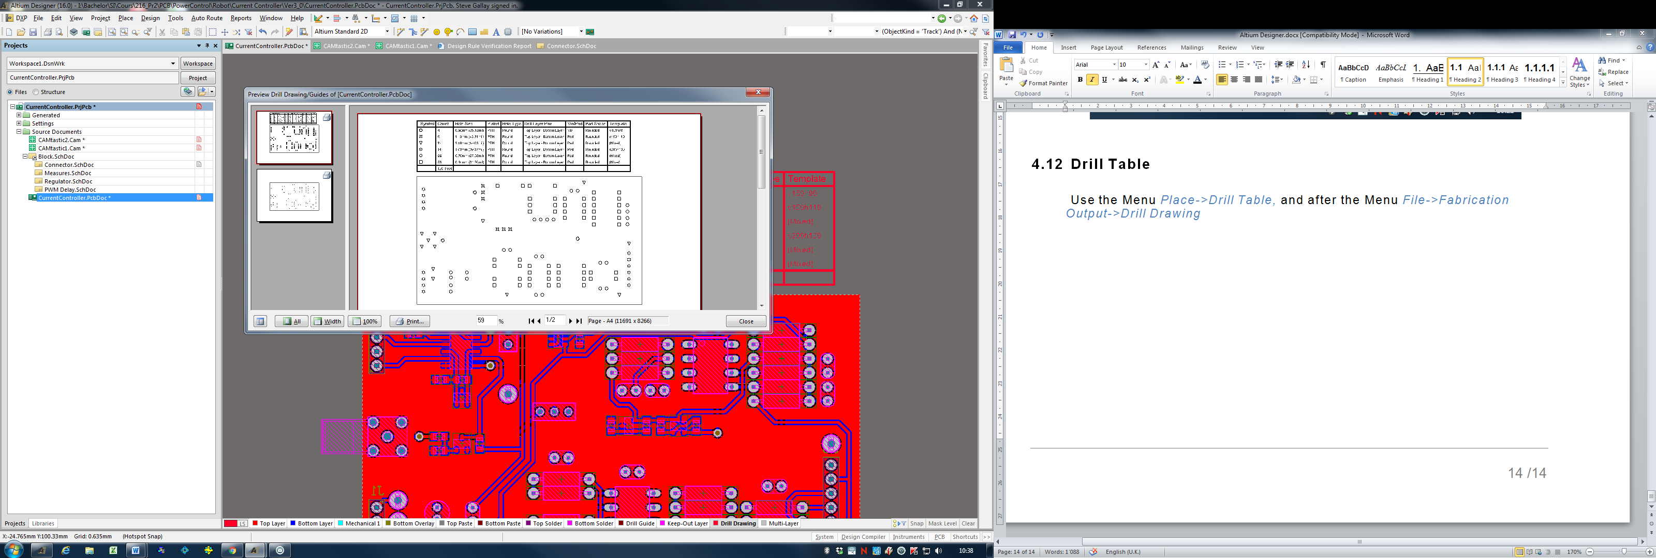

# **Tips & Tricks**

## **Help**

For open help during an action hit the **F1** key.

## **3D**

Push key **3** or key **2** for switch between 3D or 2D view.

## **Zoom**

You can easy zoom IN & OUT with **CTRL** Key + Right Mouse + Moving Mouse UP Down.

## **Selecting multiple objects**

Right click on an Object, choose **Find similar Objects**, edit all object with PCB Inspector (F11).